Name: __________________________ Math 8
Page 7
UNIT 8: NOTES ON PYTHAGOREAN THEOREM
Notes: pp. 7 - 11.

Vocabulary:
- right triangle: any triangle with one 90 degree angle.

- hypotenuse: the side of a right triangle that is opposite the right angle.

hypotenuse

- Legs: the 2 sides to a right triangle that form the right angle.

leg

leg

page 8
- pythagorean theorem: in any right triangle, the sum of the squares of the legs, equals the square of the hypotenuse.
formula: a² + b² = c²

c
a
b

Example: a² + b² = c²
5 3² + 4² = 5²
3 9 + 16 = 25
4 25 = 25 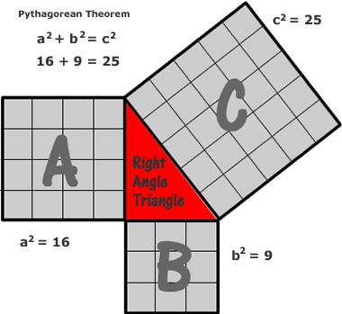
Page 9
- The converse of the Pythagorean theorem: if the sum of the squares of the two shorter sides equals the square of the longest side, then the triangle must have a right angle.

- Pythagorean triple: when 3 sides to a right triangle are whole numbers.

Example: ( from page 2 ) the 3,4, 5, triangle is a Pythagorean triple.

Other examples:
First leg second leg hypotenuse Pythagorean theorem
3 4 5 3² + 4² = 5²
9 + 16 = 25
6 8 10 6² + 8² = 10²
36 + 64 = 100
9 12 15 9² + 12² = 15²
81 + 144 = 225

Page 10
Model Problems:
- Find the length of the missing side.

x
9 cm
12 cm
a² + b² = c²
9² + 12² = x²
81 + 144 = x²
225 = x²
√225 = √x²
15 cm = x Note: The square root of 225 is also negative 15. This is a
measurement, so the negative answer is disregarded.

- Find the length of the missing side. Round to the nearest tenth.
a² + b² = c²
12 m 4² + x² = 12²
4 m 16 + x² = 144
- 16 - 16
X x² = 128
√x² = √128 x = 11.3 m
Page 11

- Find the length of the missing side and leave your answer in radical form. Show work.

9 in
6 in

x
a² + b² = c²
x² + 6² = 9²
x² + 36 = 81
- 36 - 36
x² = 45
√ x² = √45
x = √45 = 3√5

