Name: __________________________ Math 8

SCATTER PLOTS AND LINES OF BEST FIT
1. The following scatter plot shows the relationship between temperature and the number of ice creams sold. If the line of best fit represents the equation y = 3x + 5, answer the following questions on the next page.

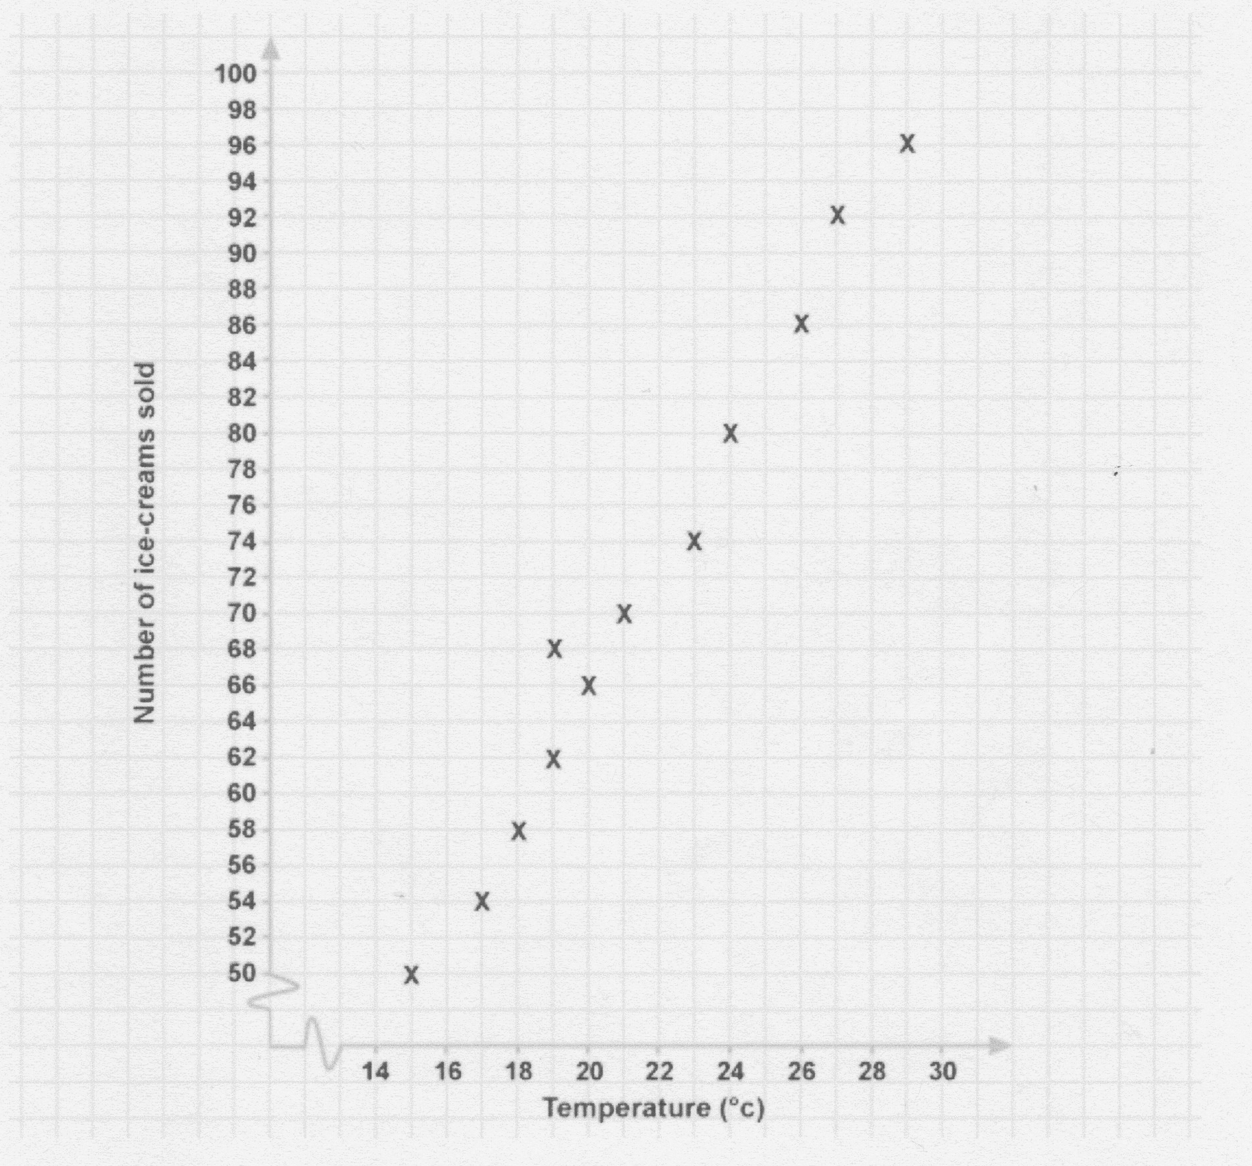
Part A: Positive, negative, or no association. ____________________

Part B: Draw a line of best fit.

Part C: How many ice creams can be expected to be sold if the temperature is 34 degrees Celsius. Explain or show work.

Part D: Explain why the answer to part C is an estimated ( predicted ) value rather than an exact value.
____________________________________________________________________________________________________________________________________________________________________________________________________________________________________________________________________________

2.
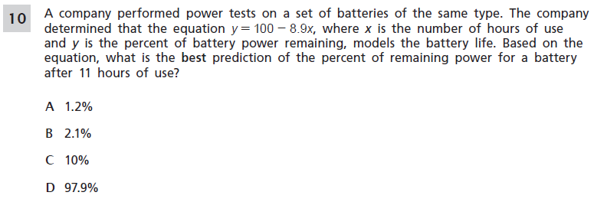
3.
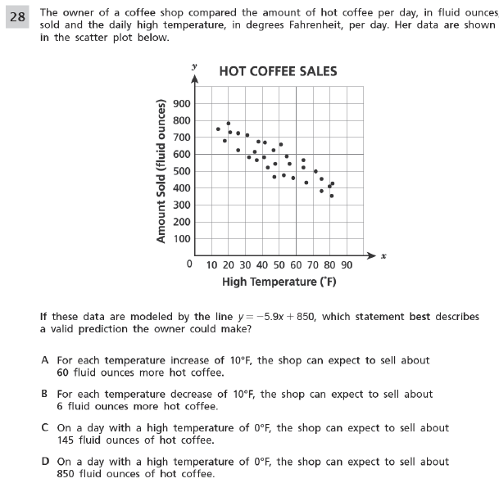

4.
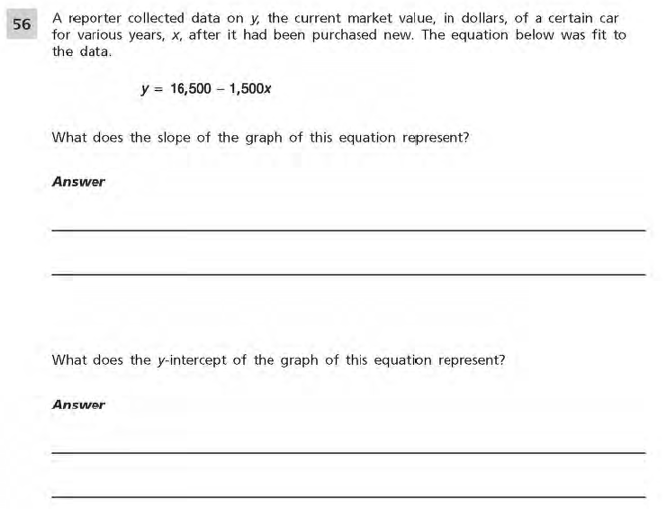

5.
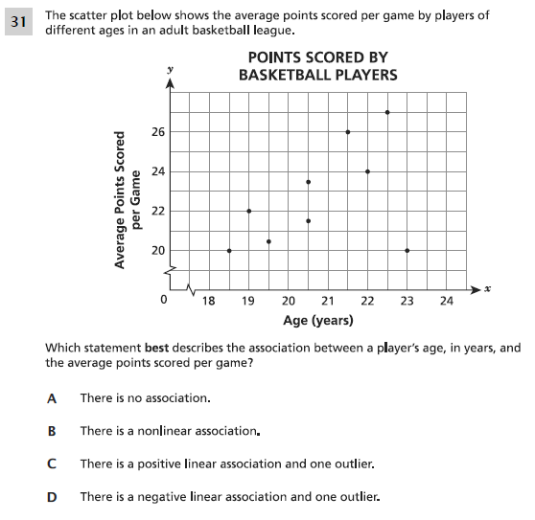
Part B: Draw a line of best fit.
Part C: Make a conjecture ( a guess ) as to the number of points a 21 year old would score? ______
Part D: Explain the meaning of the slope in the context of the problem.
_________________________________________________________________________________________________________________________________________________________________________________________________________

6.
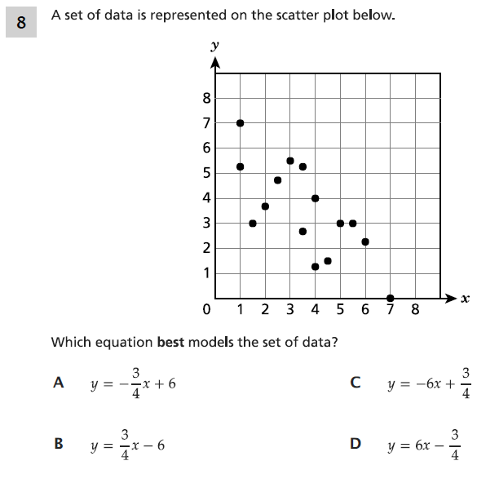

7.
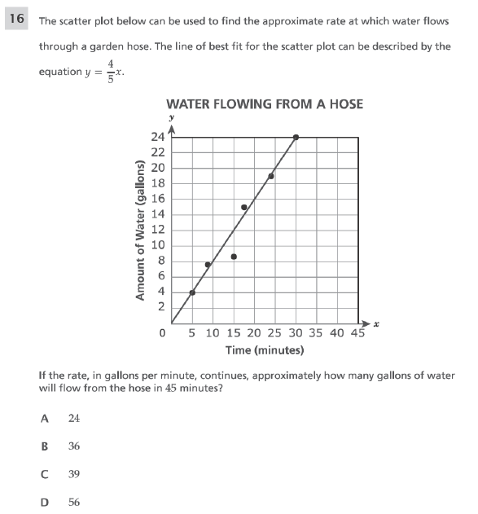
Part B: Explain the meaning of the slope and y-intercept in the context of the problem.
_________________________________________________________________________________________________________________________________________________________________________________________________________

