Name: __________________________ Math 8

COMPARING PROPERTIES OF FUNCTIONS
Problems 1 - 8: Find the rate of change and initial value for each function.
- Function 1: x y Function 2: y = 2x - 3
- 2
1 5
2 8

Rate of change = ______ Rate of change = _____
Initial value = _____ Initial value = _____

Which function has the greater rate of change? ___________________

- Function 1: y - 7 = 3x slope: _____
y-intercept: _____

Function 2: Frank walks into a store and sees a sign indicating that all CD’s
cost $18. Write a function rule that finds the cost ( c ) based on
the number of CD’s ( d ) purchased.
Function rule: _______________ Initial value = _____
Rate of change = _____
Explain how you got your initial value for function 2: _________________________________________________________________________________________________________________________________________________________________________________________________________

- Function 1:
-4
-3
-2
-1
-5
2
3
4
5
1
-5
-4
-3
-2
-1
-8
-7
-6
-8
-7
-6
5
6
7
8
4
1
2
3
6
7
8
x
y

slope =____
y-intercept = _____

Function 2: y = - 2x - 1
slope = _____
y-intercept = _____
Which function has a rate of change that is decreasing and explain why?
_______________________________________________________________________________________________________________________________
- Function 1: Gary is planning on going to the local fair. The price of
admission is $8 and the price per ticket (t) for rides is
$0.50. Write a function rule that represents the price (p)
that Gary will spend based on the number of tickets (t) he
buys.

Function rule: __________________ Initial value = _________
Rate of change: ____________

Function 2:
-4
-3
-2
-1
-5
2
3
4
5
1
-5
-4
-3
-2
-1
-8
-7
-6
-8
-7
-6
5
6
7
8
4
1
2
3
6
7
8
x
y
slope = _______
y-intercept = ________

Describe the relationship between the each rate of change. ________________ _________________________________________________________________
- Function 1: 4x + 2y = 6 slope = _______
Initial rate = ________

Function 2: Complete the table:
y = - 3x + 6
x y
1 Rate of change = _______
2 y-intercept = ________
3
4

Describe what is going on with the rate of change between both functions.
______________________________________________________________________________________________________________________________________

- Function 1: Complete the table.
x 0 1 2 4 5 6 9 Rate of change = ______
y 5 10 15 Initial value = ________

Function 2:

22 slope = _____
20 y-intercept = _______
18
16
14
12
10
0 1 2 3 4 5 6

Describe what is going on with the rate of change in function 2.
_________________________________________________________________________________________________________________________________________________________________________________________________________

- Function 1: A number y is 2 less than 5 times a number x.
Function rule: _____________
slope = ________
y-intercept = _________
Function 2:

32 Rate of change = _______
29 Initial value = _________
26
23
20

0 1 2 3 4 5 6 7
Which function has the greater rate of change? _____________________

- Function 1: Complete the table.
x y
1 6 Rate of change = ______
2 2 y-intercept = ________
3 - 2 Function rule = __________
5 - 10
8
12

Function 2: Jack has $115 in his bank account. He wants to put $20 into his account each week. Write a function rule that shows how much is in Jack’s account (a) after a certain number of weeks ( w ).
Function rule: ____________
slope = _________
Initial value = _________

Describe the difference between the rate of change for each function.
_________________________________________________________________________________________________________________________________________________________________________________________________________

Problems 9 - 12, answer the questions and compare.
- Function 1:

x y rate of change = __________
2 2 y-intercept = _________
4 5 function rule = ____________
6 8
8 11

Function 2:
-4
-3
-2
-1
-5
2
3
4
5
1
-5
-4
-3
-2
-1
-8
-7
-6
-8
-7
-6
5
6
7
8
4
1
2
3
6
7
8
x
y

Slope = _______
y-intercept = _____
function rule = _______

Greater rate of change: _________________________
- Function 1:
Gary’s gym offers a membership fee of $125 and charges $40 a month.
Rate of change = _________________
y-intercept = _________
function rule = __________

Function 2: The graph below shows how a member pays at Ron’s Gym.

Number of Months
Amount Charged
0
150
300
350
400
450
1
2
3
4
250
200
100
5
6
7
Ron's Gym

Slope = _______
Initial Value = _______
Function Rule = _______

Part B: Which Gym offers the better deal after 6 months and by how much? Show work.

Part C: What does the rate of change represent in both functions?
_________________________________________________________________________________________________________________________________________________________________________________________________________

- Function 1: Gym A offers a membership for $40 a month and a $80 sign up fee.

Slope = __________
Initial value = _________
Function rule = ___________

Function 2: Gym B offers a $50 a month membership fee and no sign up fee.

Slope = _______
y-intercept = ________
Function Rule = ___________

Part B: Which gym offers the better deal after 6 months? Show work.

- Function 1:
x y Rate of change = _________
- 6 - 10 y-intercept = _________
- 3 - 3 function rule = __________
3 11

Function 2: 3y - 4x = 3
Slope = __________
Initial value = _________

Which function has the greater rate of change? ____________________

13.
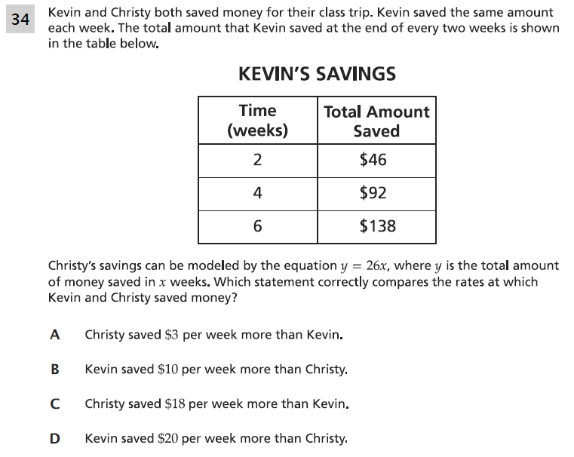

14.

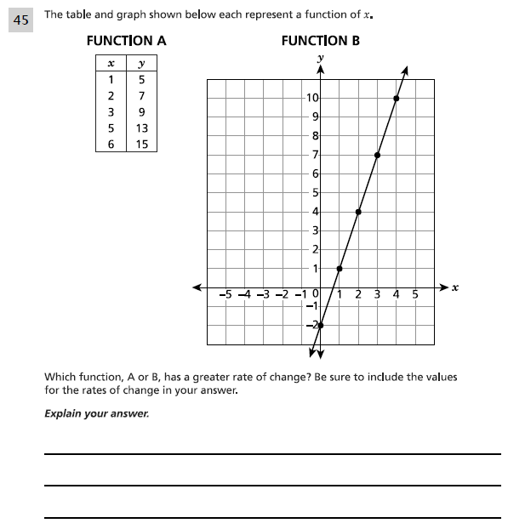

15.

