Name: ______________________________ Math 8

FINDING EQUATIONS OF THE LINE
Problems 1 – 10, write an equation of a line that has the given slope and that passes through the given point. Show work.
- m = 2, ( 1, 4 ) 3. m = 2, ( - 3, 4 )

- m = - 3, ( - 2, - 1 ) 4. m = 1, ( 6, 2 )

- m = - 4, ( - 1, 6 ) 7. m = - 1, ( 2, 3 )

- m = 4, ( - 1, 0 ) 8. m = 0, ( 4, - 2 )

- m = 3, ( 4, 7 ) 10. m = - 2, ( - 1, 3 )

Problems 11 – 20, write the equation of the line that passes through the given points. Show work.
11. ( 1, 4 ), ( 3, 8 ) 12. ( 3, 1 ), ( 9, 7 )

13. ( 6, 2 ), ( 10, 14 ) 15. ( 3, - 1 ), ( 6, 8 )

14. ( - 2, - 5 ), ( - 1, - 2 ) 16. ( 0, 0 ), ( - 2, 12 )

17. ( 8, 7 ), ( 6, - 7 ) 19. ( - 1, 7 ), ( - 4, 4 )

18. ( 4, - 1 ), ( 7, - 10 ) 20. (4, 1 ), ( 7, 13 )

21.
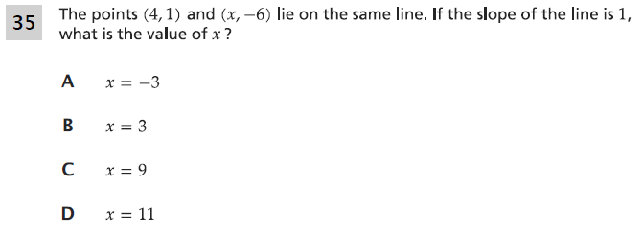

22.
