Name: _____________________________ Math 8
Page 1
UNIT 6: NOTES ON SCATTER PLOTS.
Pages 1 – 5.

Vocabulary:
- Scatter plot: a graph that relates two groups of data.

- Bivariate data: information involving two variables.

- Clustering: when sets of data are close together.

- Linear association: when sets of data are clustered to show a high positive association or high negative association.

- Nonlinear association: when sets of data ARE NOT clustered to show a high positive association or high negative association.

Page 2
- Positive association: when two sets of data increase together.

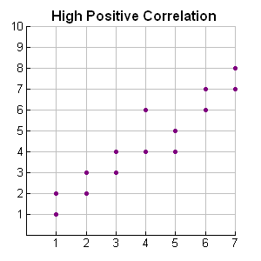
The points are clustered as to resemble a rising straight line with a positive slope.

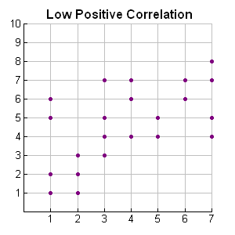
While the points tend to be rising, it is not a clear positive relationship since points are not clustered to show a clear straight line.
Page 3
- Negative association: when one set of data decreases as the other increases.
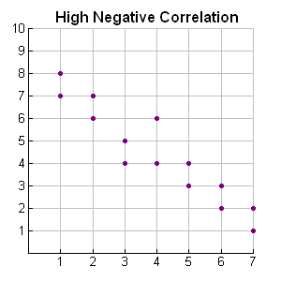
The points are clustered as to resemble a falling straight line with a negative slope.
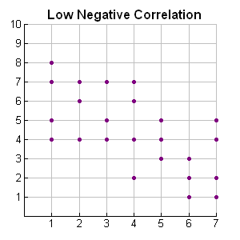
While the points "tend" to be falling, it is not a clearly negative relationship since points are not clustered as to show a clear straight line.
Page 4
- No association: when 2 sets of data are not related.
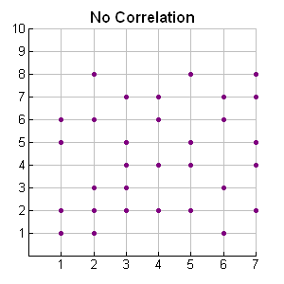
There is no way of determining from these points, if the pattern is rising or falling. There is no evidence of a straight line.

- Outliers: sets of data that are much higher or lower than the other sets of data.

•
outliers
••••
•••••

•

Page 5
- Line of best fit: a straight line that best represents the data on a scatter plot. The line may pass through some of the points, none of the points, or all of the points.

•
• • •
•
•
• •

