Name: __________________________ Math 8

GRAPHING AND INTERPRETING SCATTER PLOTS
Problems 1 - 2: Create a scatter plot for each of the tables and be sure to give each scatter plot a title, label each axis, and give an appropriate interval. Be sure to answer the given questions that go with each problem.
- The table shows the relationship between the number of hours spent studying and regents test score results.

Study Hours | Regents Score
3 | 80
5 | 90
2 | 75
6 | 80
7 | 90
1 | 50
2 | 65
7 | 85
1 | 40
7 | 100

Part B: Positive, negative, or no association? _________________
Part C: Linear or non-linear? ______________________
Part D: Draw a line of best fit.

2. The table below shows the data students collected on their test scores and the number of hours they watched television the previous day.

Hours watched | Test scores | Hours watched | Test scores
0 | 100 | 2 | 80
0.5 | 89 | 2.5 | 65
1 | 82 | 3 | 68
1 | 90 | 3.5 | 60
1 | 95 | 4 | 65
1.5 | 85 | 4.5 | 55
2 | 70 | 5 | 60

Part B: Positive, negative, or no association? ___________
Part C: Linear or non-linear? _____________
Part D: Draw a line of best fit.

- The scatter plot below shows the data for the amount of paint used to paint signs of various lengths.

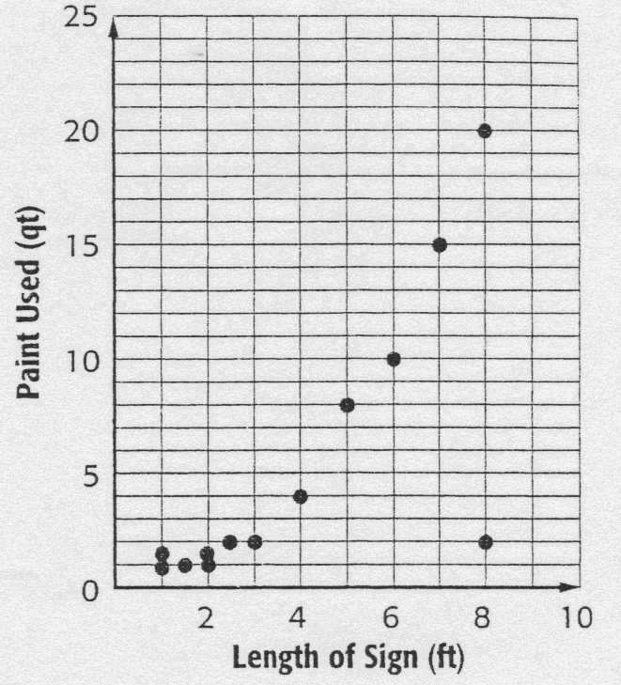

Part A: Positive, negative, or no association? __________________
Part B: Linear or non-linear? ________________________
Part C: At what lengths does clustering occur in the scatter plot? _______________________________________________________________
Part D: Identify an outlier? ____________________
Problems 4 – 5, explain whether the scatter plot of data for each of the following shows a positive, negative, or no association.





