Name: ___________________________ Math 8

AREA AND VOLUME
Model Problems:
- Find the volume of the cylinder and round to the nearest tenth.
4 cm Note: The volume of a figure is always the area
of the base ( big B ) times the height. Since
7 cm the base is a circle, the volume formula is
the area of the base ( πr² ) times the height.
V = Bh
V = πr²h
V = π • 4² • 7
V = π • 16 • 7
V = 351.9 cm³

- Find the volume of the cone and round to the nearest tenth.
3 m Note: A cone is 1/3 of a cylinder, therefore
the formula is:
9 m V = (1/3)πr²h
V = (1/3) • π • 3² • 9
V = (1/3) • π • 9 • 9
V = 84.8 m³
- Find the volume of a sphere with a radius of 5 inches. Round to the nearest hundredth.
V = (4/3)πr³
V = (4/3) • π • 5³
V = (4/3) • π • 125
V = 523.60 in³

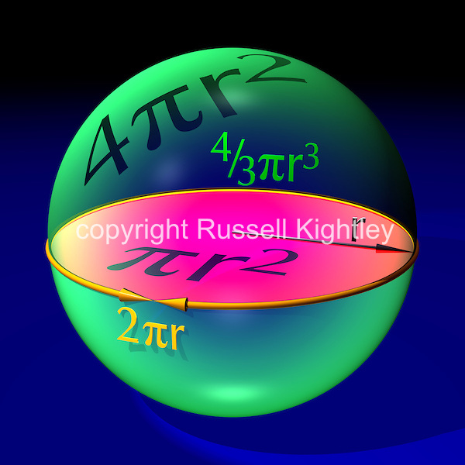
- Find the surface area of the cylinder. Leave answer in terms of π.
6 cm S.A. = 2πr² + 2πrh
10 cm S.A. = 2 • π • 6² + 2 • π • 6 • 10
S.A. = 2 • π • 36 + 2 • π • 6 • 10
S.A. = 72π + 120π
S.A. = 192π cm²
Problems 1 – 5, find the area of each figure. Round to the nearest tenth when necessary and show work.

5m

4 m

6 in

- 5 cm

5 cm

- 3 cm
4 cm

5 cm

- 12 in

5 in

Problems 6 - 16, find the volume and round to the nearest hundredth when necessary. Show work.
- 5 m
5 m
5 m

- 6 in
10 in

- 6 cm

11 cm

- Find the volume of a sphere with a radius of 4 meters.

- Find the volume of a sphere with a diameter of 6 inches.

- 13 cm

7 cm 2 cm

- 8 m
1 m

- 3 in

7 in

- Find the volume of a sphere with a radius of 8 meters.

- 3 cm

9 cm

- 2 in
5 in

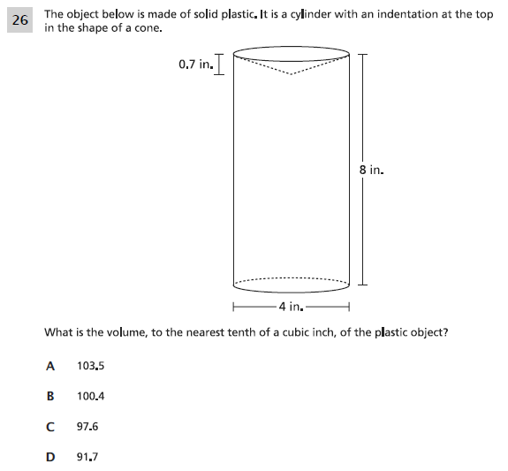

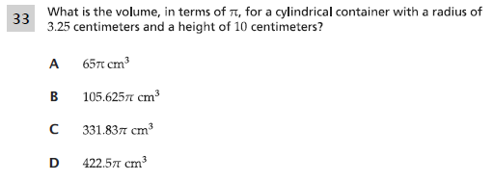

Problems 19 - 22, find the volume and show work. Round your answers to the nearest tenth when necessary.
- James wanted to plant pansies in his new planter. He wondered how much potting soil he should buy to fill it. Use the measurements below to find out how much potting soil is needed.
40 cm

100 cm

- How much yogurt is needed to fill the cone?
3 cm

5 cm

- How much air is needed to fill a soccer ball with a radius of 9 inches?

- The local theater sells popcorn in two different containers as shown below.
3 in 6 in

6 in 8 in

5 in
How much more popcorn does the box hold than the cone?

Problems 23 – 24, find the volume and leave your answers in terms of π. Show work.
- James wants to plant tulips in his new planter. The planter is cylindrical in shape. The base has a diameter of 40 cm and the height of the cylinder is 100 cm. Find the volume. l

- A dish contains a spherical scoop of ice cream with a diameter of 2.4 inches. What is the volume of the ice cream?

Problems 25 – 26, find the diameter of each figure. Show work.
- A cone has a height of 5 cm and a volume of 15π cm³.

- A sphere with a volume of 972π m³.

