Name:___________________________________________

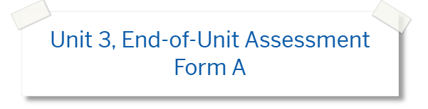

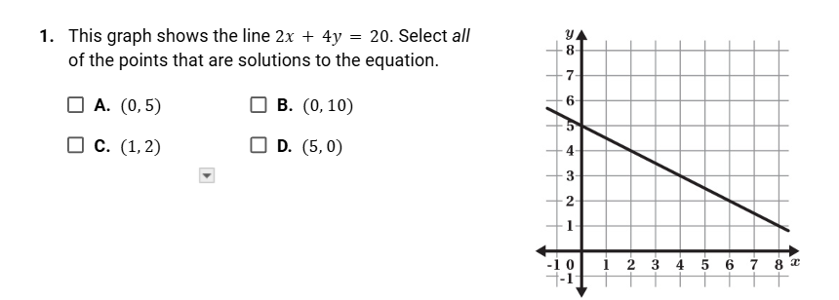

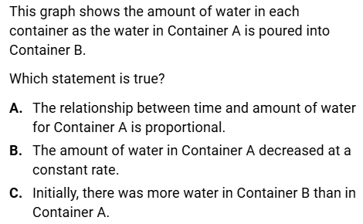

2.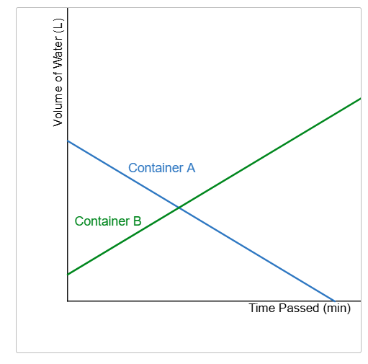



3. 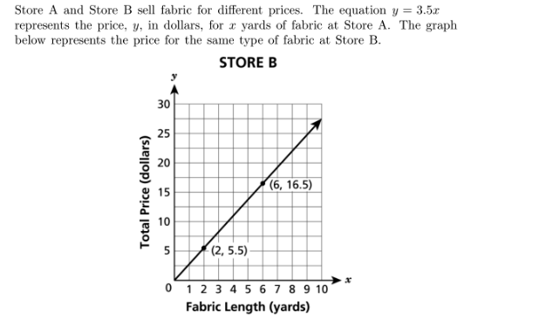

Part A: What is the unit rate for the price of fabric, per yeard, at Store A?

Part B: What is the unit rate for the price of fabric, per yard, at Store B?

Part C: How much more would the price of 9 yeards of fabric be at Store A than at Store B?

4. Which of the following is th equations for the line for the graphed below:

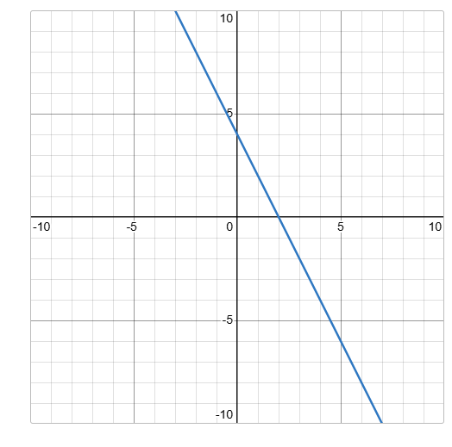



5. Write the equation of the line graphed below.

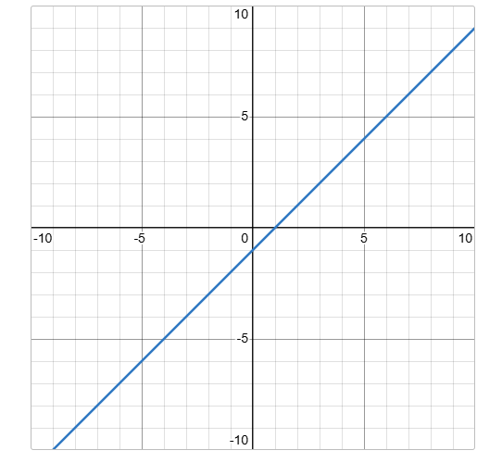

**_____________________________________________**

**6.**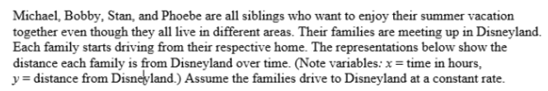

|  |
| --- |
| **MIchael’s Family**  y=95-55x |
| **Bobby’s Family:**  Bobby’s Family lives 120 miles from Disney land and drives 60 MPH. |
| **Stan’s Family:** |
| **Phoebe’s Family:** |

**Part A: Which family is traveling the fastest? Show work to support your answer.**

**Part B: Which family had the farthest to travel? Show work to support your answer.**

**7.** A cell phone plan costs $300 to start. Then there is a $50 charge each month.

Part A: Write an equation to represent the total cost, , to use the cell phone plan for x months.

Part B: What is the total cost (startup fee and monthly charge) to use the cell phone plan for 2 months?

**8. Graph $y=-1/2x + 8$ on the coordinate grid below.**

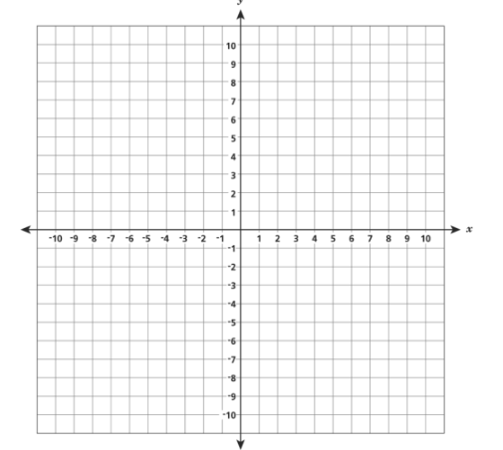

|  |  |
| --- | --- |
| **x** |  |
| **-4** |  |
| **-2** |  |
| **0** |  |
| **2** |  |
| **4** |  |

9. Function M is represented by the table below. Function T is represented by the

equation y= 8x+ 3. Which of the following statements is true?

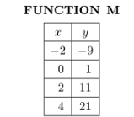

1. Function M has a greater rate of change and a greater y-intercept than Function T.
2. Function T has a greater rate of change and a greater y-intercept than FunctionM.
3. Function M has a lower rate of change and a greater y-intercept than Function T.
4. Function T has a lower rate of change and a greater y-intercept than Function T.

**10. What is the slope of the line on a coordinate plane that passes through the points (2,2) and (-1,-2)?**

**11. Alex opened a savings account with an initial deposit of $50. Each month, he deposits the same amount of money. He uses the equation t = 50+ 25m to determine, t, the total amount of money in his saving account in m months. What is the rate and what is the meaning of the rate?**

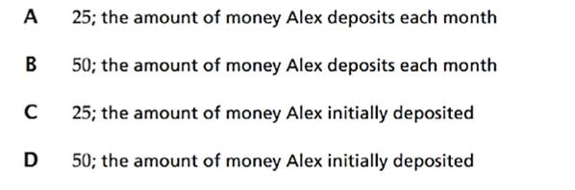

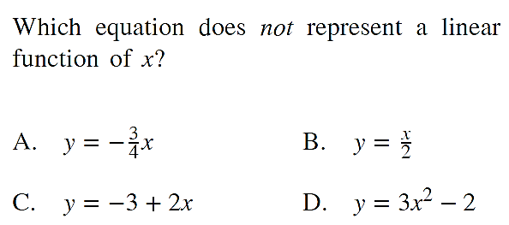

**12.**

**13. 14.**