Name: ___________________________________ Math 8

Final Exam Review Packet

- Which equation of a line has a slope of ½ and a y-intercept of 4?

A. y = - 4x + ½ C. y = ½ x + 4

B. y = ½ x - 4 D. y = 2x - 4

- Simplify the expression ( 3² )⁴.

A. 3⁶ C. 3⁸

B. 6⁶ D. 9⁸

- What is the solution of 4x + 8 = - 2( 2x - 4 )?

A. 0 C. 8

B. No solution D. infinite number of solutions

- What is the complement of a 10 degree angle?

A. 80 degrees C. 10 degrees

B. 170 degrees D. 350 degrees

- If A( 2, 5) is translated 3 units to the left and 5 units up, where will A’ end up?

A. ( 5, 10 ) C. ( -1, 0)

B. ( - 1, 10) D. ( 3, 5 )

- Between which 2 numbers is the cubed root of 200?
- 4 and 5 C. 6 and 7
- 5 and 6 D. 7 and 8

- What is the slope of the line that passes through the points ( 2, - 3) and ( - 5, 7 ) ?
- 10 C. – 10/7
- – 7 D. – 7/10

- Which of the following is a rational number?
- -√4/9 C. π
- 4/0 D. √3

- What is the equation that has a slope of - 4 and goes through the point ( 3, - 14 )?
- y = - 4x - 2 C. y = - 4x + 11
- y = 11x - 4 D. y = 3x - 4

- 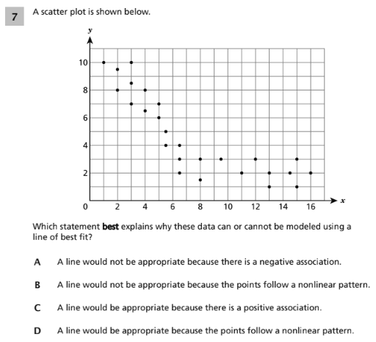

- Identify the domain and range from set A below, then identify the relation as a function or not and explain why.

Set A = { ( - 2, - 1 ), ( - 1, - 1 ), ( 0, 1), (1, 4 ), ( 1, 8 ) }

Domain = _________________________

Range: ____________________________

__________________________________________________________________________________________________________________________________________________________________________________________________________________________________________

- Mark wants to join a fitness club and he compares the following:

Club A offers a one time fee of $60 plus $35 a month. Club B offers no fee and $50 a month.

Part A: Write a function rule for each club.

Club A: ____________________

Club B: ____________________

Part B: When will the price of both clubs be the same? Show work.

Part C: Explain the meaning of the rate of change and the initial value in the context of the problem.

________________________________________________________________________________________________________________________________________________________________________________________________________________________________________________________________________________________________________________

- The table below shows the number of stocks sold after a certain number of hours.

Number of hours (h) number of stocks (s)
2 120
4 240
6 360
8 480

Part A: Write a function rule for number of stocks sold (s) after a certain number of hours (h).

Function rule: ______________________

Part B: How many stocks will be sold after 14 hours? Show work.

- Write a function rule for the following graph.

Function rule: ____________________________
-4
-3
-2
-1
-5
2
3
4
5
1
-5
-4
-3
-2
-1
-8
-7
-6
-8
-7
-6
5
6
7
8
4
1
2
3
6
7
8
x
y

- Explain why the following equation is not a linear function.

y = 2x² + 3x - 1

_________________________________________________________________________________________________________________________________________________________________________________________________________________________________________________________

- Solve and check the following system of equations. Show work.

3x + 5y = 105 check:

3x - 4y = - 30

Solution: ______________
- Solve the following system of equations graphically:

y = x - 3
y = - x + 5

-4
-3
-2
-1
-5
2
3
4
5
1
-5
-4
-3
-2
-1
-8
-7
-6
-8
-7
-6
5
6
7
8
4
1
2
3
6
7
8
x
y

Solution: ______________

- Describe the series of transformations if the pre- image is in the first quadrant.
-4
-3
-2
-1
-5
2
3
4
5
1
-5
-4
-3
-2
-1
-8
-7
-6
-8
-7
-6
5
6
7
8
4
1
2
3
6
7
8
x
y

___________________________________________________________________________________
_______________________________________________________________________________________________________________________________________________________________________________________________________________________________________________________________________________________________________________________________________________________________________________________________________________________________

- Describe what happens to the perimeter of a triangle after a dilation of a scale factor of 3?

_________________________________________________________________________________________________________________________________________________________________________________________________________________________________________________________

Part B: Explain why this is not a rigid transformation.

_________________________________________________________________________________________________________________________________________________________________________________________________________________________________________________________

Part C: If the interior angles of the pre-image are 40 degrees, 60 degrees, and 80 degrees. What are the measures of the interior angles of the image?

___________________________________________________________________________________

- Find the volume of the cylinder below. Round your answer to the nearest hundredth and show work. Use V = r²h.

4cm

8cm

- Find the volume of a cone with a radius of 5 inches and a height of 12 inches. Use V = r²h and show work. Round to the nearest tenth.

- Find the measure of < ABC, show work.

A
70⁰

135⁰
B C D

Problems 23 – 24, use the figure below. Lines a and b are parallel to each other.

1 2
a
3 4

5 6
b
7 8

- Name a pair of congruent angles. ___________

- Name a pair of supplementary angles. ___________

Problems 25 – 27, identify as rational, irrational, or not real and explain why.

- √5.29
________________________________________________________________________________________________________________________________________________________

- ⅓

______________________________________________________________________________________________________________________________________________________________________

- π

______________________________________________________________________________________________________________________________________________________________________

- Solve for the missing side of the right triangle. Show work and leave in radical form.

18 m
x

12 m

- Graph triangle ABC with the following vertices; A ( 3, 4 ), B ( 3,8),
C ( 8, 3 ). Reflect triangle ABC over the y-axis. Then rotate triangle A’B’C’ 90 degrees counter-clockwise.
-4
-3
-2
-1
-5
2
3
4
5
1
-5
-4
-3
-2
-1
-8
-7
-6
-8
-7
-6
5
6
7
8
4
1
2
3
6
7
8
x
y

Part B: Explain why this is or is not a series of rigid transformations.
_________________________________________________________________________________________________________________________________________________________________________________________________________________________________________________________

- Graph triangle ABC with the following vertices; A ( - 2, 1 ), B ( - 4, 3), and C ( 0, 3 ). Translate triangle ABC 3 units to the right and 4 units down. Then dilate triangle A’B’C’ by a scale factor of 2.
-4
-3
-2
-1
-5
2
3
4
5
1
-5
-4
-3
-2
-1
-8
-7
-6
-8
-7
-6
5
6
7
8
4
1
2
3
6
7
8
x
y

Part B: Explain what happens to the perimeter of the triangle after it is dilated by a scale factor of a 2.
____________________________________________________________________________________________________________________________________________________________________________________________________________________________________________________________________________

- Solve for angles ABD and HFG if lines CD and EG are parallel. Show work.

A
C B 3x - 8 D

E F G

9x + 8

H

