Pears: The Pear-fect Winter Snack!
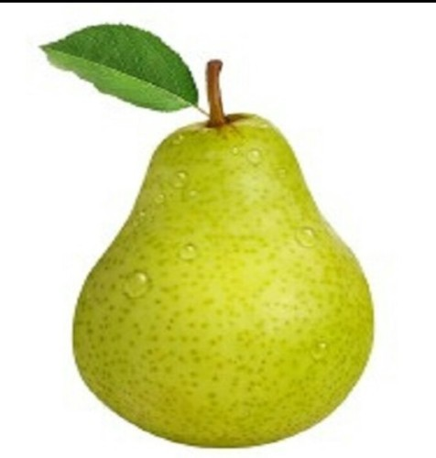

Vitamin C: Helps you grow, build strong muscles, bones, and teeth

Fiber: Keeps things moving and fills you up! Make sure to eat the skin of the pear, because that’s where you get the most fiber.

Antioxidants: Protects your heart!

Vitamin K: Helps your body heal scrapes and cuts quickly

Copper: Helps prevent colds and other sicknesses

Potassium: Helps send messages from your brain to your body! It also helps prevent disease and keeps your muscles strong.

Hydration: A pear is 84% water! This helps with keeping you hydrated throughout the day.

