Antioxidants are healthy!

Antioxidants are good for us because they can kill free radicals before they attack our healthy cells

Some examples of foods high in antioxidants include:
- Blueberries
- Raspberries
- Purple/red grapes
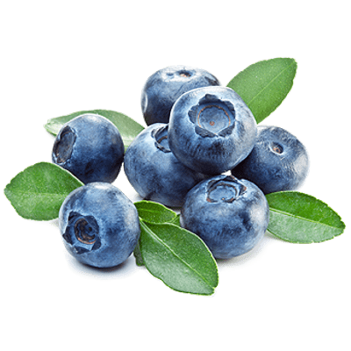
- Dark chocolate
- Kale
- Beans
- Beets
- Artichokes
- Nuts

