Reference section

A Guide To Song Writing:

19

An Original Song with Lyrics

Name:__________________________________________________ Block:___________

Music In Our Lives
Mr. Halpin

Revised 2/15/17

An Original Song
With Lyrics

Revised 1/31/2010

INTRODUCTION

Benefits of Composing an Original Song with Lyrics
Listening to music is one of the most popular pastimes enjoyed by people all over the world. Whether listening to recordings or attending live concerts, music has the ability to inspire and give pleasure to almost anyone. For many students and professionals, playing a musical instrument is an even more rewarding experience. But understanding how music is constructed; where scales and chords come from; the relationship between Major and Minor keys; how music is composed through elements like melody and harmony – all of which we will be learning about – promotes deeper understanding and appreciation for all music experiences. These are kinds of experiences that help to develop chances of having a peak experience, and are what we will be exploring. Did you know that there is even current scientific research which proves that studying music in this way improves I.Q. scores? – It actually makes people smarter!

So how is a song written?
Many different musical elements must come together as one to create the end-product of a song. There are endless ways to approach song writing. Song writing is a creative art that is guided by musical choices. The basic skills a songwriter must obtain, however, all come from studying what is called music theory. Music Theory incorporates all of the principles and rules used for music making, and its understanding is crucial to composing music that will sound musical. A musician’s artistic approach of choices is only limited by a “good ear” and their knowledge of music theory.

Let's look at some choices a musician in a rock band might explore in order to generate ideas for a song. A rhythm guitarist, for example, might come up with a way to play the rhythm of a cool new chord that they’ve just learned. This chord might then be included in what's called the Chord Progression – a succession of chords that provide the harmony for a song. But in order to do this, the guitarist has to make a skillful choice of what chords will be used to create the desired musical effect. For example; Will the chords used be Major, minor, or diminished? Will all the chords come from the same key? Will the chords gradually modulate to another key? Will the chords come from chord progressions used in pop music?-and so on. These musical choices require developing what’s referred to as your musicianship – all of your musical knowledge.

Where Do Musical Ideas Come From?
Having ideas from music theory knowledge is not the only way to create a song. A songwriter or collaboration of writers (like in a band) should also know what will "sound good" together. This might be done “by ear” – choosing something that sounds good to the listener, it might be using musical theory skills to make a musical choice, or some kind of combination of the two. As a beginning songwriter, you will get to explore the basics of both musical creativity and music theory. Once you learn the basics of writing a simple song, the possibilities are endless! Just remember - the more you develop your listening skills and know about music theory, the more choices you have, which means you can be more creative composing music that is your own. So put some thought behind your creativity- have fun- and enjoy what you will create – your very own song with lyrics. ☺

-Mr. D’Alberto, MIOL 2009

Page 2
******************************************************************************************
To Compose Your Original Song with Lyrics...

I. CHOOSE A TOPIC FOR YOUR LYRICS

STEP 1. Generate a list of main topics or ideas for your lyrics and then choose
the topic. Write your list on the Lyric Topics sheet provided.

TO GET YOU STARTED
A main topic might come from the ideas in the following list:

- Food
- Sports
- A Hobby
- Telling a story
- Send a Positive Message to others
- Write a Jingle for a commercial
- Use a Creative Writing piece
- Write a Love Song
- Write a Fun, Silly Song
- Write a Holiday song

Whatever you choose to write about, be creative, use your own ideas, and
HAVE FUN WITH IT!!!!!☺
…The more creative you are with your lyrics = a more interesting original song

*See Lyric Topics worksheet

Page 3
********************************************************************************************
Revised 4/3/13
II. COMPOSE YOUR LYRICS
STEP 1. Write your lyrics for Verse I and Verse II. Your verses should tell the story or set the mood for your
song. Write one phrase, thought, or group of words about your topic directly below the line on the
Lyrics & Rhythm sheets. Try to make your lyrical lines less “wordy” like a
sentence. Instead, try to capture the idea for the line using a few strong, direct words.
Do this for each of the four lines on the page. You will write two Verses for this song.

NOTE: Before you begin on the Verse worksheets, write a rough draft out on the back of the Verse sheet.
This approach will help you to get your words out on paper, and then you can choose the phrases you like best
to copy onto your Lyric/Rhythm sheets.

*Follow the Lyric Guidelines below in your writing when completing your sheets.

* Lyric Guidelines:

1. USE A PENCIL!!!!!!! You will be making many revisions and corrections
during the song writing process, so it is critical to use an erasable writing tool. Any work that is not
completed in pencil for this project will not receive ANY CREDIT!

2. Use a MAXIMUM of 6 WORDS for each line of lyrics. Lines should capture a thought or vision
with as little words as possible.

3. DO NOT continue a thought or phrase to the next line. Continuing the thought to the next line
will disrupt the melodic phrase later.

4. Space the words out so that the syllables can be easily separated. This will aid in setting the words to a rhythm.
(Words with two or more syllables must be hy-phen-a-ted)

5. CHECK the correct spelling of any word you are not sure of in a dictionary.

*NOTE: TO RHYME OR NOT TO RHYME…
When you write lyrics for the next line, you may choose to end your phrase or thought with a rhyming word as in most
popular music. Or- you may choose to be different from the mainstream and not have a rhyming scheme at all.
If you choose to make your lyrical lines rhyme, you may have every other line rhyme – or-
you can even choose to “mix it up”, with some other combination of rhyming words that you like.

Page 4
********************************************************************************************
Revised 4/3/13
STEP 2. Complete your CHORUS lyrics. Be sure to follow the * LYRIC GUIDELINES when adding lyrics to
your My Original Song: CHORUS page. Try to capture the main theme of your song in this section.
You may want to take a phrase that you write in this section and use it for your title later.
Give your lyrics a Hook

To help the Lyrics in your Chorus produce more of a catchy, Lyrical “Hook”…
Apply a format used in popular music from one of the following options.
*Note how the other musical elements contribute to creating the Hook.

Option #1 (“I Love Rock N’ Roll” Joan Jett and the Blackhearts)

LYRICS: This hook is created by repeating the phrase in the 1st and 3rd line to emphasize the theme.
MELODY: Listen for the melodic phrase to repeat in these lines as well
FORM: Intro – Verse - CHORUS

Chorus:
I love rock 'n' roll
So put another dime in the jukebox, baby
I love rock 'n' roll
Come and take the time and dance with me

Option #2 (“Saturday Night” Bay City Rollers)

LYRICS: This hook is created by repeating all four lines, placing extreme emphasis on one thought.

MELODY: None. This chorus employs individual letters and spoken word in a rhythmic chant that is repeated for all lines.

(This chanting technique can also be applied to numbers, or a combination)

FORM: CHORUS – Verse

Chorus
S-A, T-U-R, D-A-Y… Night
S-A, T-U-R, D-A-Y… Night
S-A, T-U-R, D-A-Y… Night
S-A, T-U-R, D-A-Y… Night

Option #3 (“Don’t Let Me Down” The Beatles)

LYRICS: This hook is also created by repeating all four lines, placing extreme emphasis on one thought.
MELODY: Listen for the 1st melodic phrase to be repeated in the 3rd line. The 2nd and 4th are the same as well.
FORM: (short) Intro – CHORUS - Verse

Chorus
Don’t Let Me Down…
Don’t Let Me Down…
Don’t Let Me Down…
Don’t Let Me Down…

Page 5
********************************************************************************************
Revised 4/3/13

Understand How Lyrics Are Set To Music
The English language places subtle stresses on words when they are pronounced. A stress in a word can come in many forms – a “punchy” kind of a stress from a consonant sound, such as the sound of the letter T - a lengthy kind of stress from a syllable like “ade” in the word le-mon-ade, and so on. Every word is different; therefore this process of identifying a stressed syllable in a word may take some practice.

When words are set to music, a stressed syllable should fall on a stressed part of a beat in order to sound musical. When a syllable falls on a downbeat (the first part of a beat) it will rhythmically have more weight, or stress. Therefore, to make words have good rhythmic “flow” in music, all stressed syllables should match the stress that occurs on the downbeat. There are exceptions in more rhythmically demanding music, however this approach is a good place to start. In addition to music having a stress on the downbeat, music using a 4/4 Time Signature --known as common time-- carries an even heavier stress on beat 1. These stresses are considered more when working to achieve rhythmic flow in a lyrical line. We will hear the effects that common time has on rhythmic stress later on in the project. Understanding these rhythmic stresses in music should come easily, as most popular music is in common time.

When we learn to match the stressed syllables in words with the stressed beats in music, we’re able to write a song with lyrics that sound more musically pleasing. This is why a good choice of rhythm for lyrics is so very important. Once you have identified the stressed and unstressed syllables in your lyrics, you can compose rhythm that will work musically. Unstressed syllables in words are less rhythmically flexible. They should fall on the unstressed part of the beat – known as the Upbeat. Stressed syllables will begin on the downbeat in most cases. Later when we begin to experiment with rhythm variation we will see that more than one rhythmic choice is always possible for a word or a syllable. You will see how rhythm can make a great difference in music, however we aspiring songwriters must remember the GOLDEN RULE: in words with more than one syllable—

The UNSTRESSED syllables should always fall on the Upbeat

Try the following Syllable Exercises to recognize the Stress:
Say the word out loud as you would naturally when communicating and then identify which syllable has more stress, or “weight”. If you have difficulty, try exaggerating the stress on each syllable to hear the differences. Speak the word with a heavy stress or accent on the first syllable, then place a heavy stress on the second syllable. Which sounds nearest to the spoken word? Say the words in the following examples, while listening for the stress placed on the syllable that is shaded.

Example 1a:
Listen for the stress in some two-syllable words.

1. par-ty 2. sing-ing 3. gui-tar 4. a-bout

Example 2a:
Listen for the stress in some three and four-syllable words.

1. yes –ter – day 2. for – ev – er 3. val – en – tine 4. A – mer – i - can

Page 6
********************************************************************************************
Revised 4/3/13
III. PREPARE THE SYLLABLES IN YOUR LYRICS FOR RHYTHM
Identify the Syllable

STEP 1. Underline each syllable included in your lyrics. Be sure to include one-syllable words.

See these rockin’ examples:

a.) rock b.) gui tar c.) e lec tric

STEP 2. Separate words that have more than one syl - la - ble, with a hyphen (-).

See these ”love-ly” examples:

a.) love-ly b.) for-e-ver c.) val-en-tine
~~~~~~~~~~~~~~~~~~~~~~~~~~~~~~~~~~~~~~~~~~~~~~~~~~~
Identify Stressed Syllables

STEP 1. Circle all one-syllable words.

One-syllable words have just one sound, therefore they have only one stress.

Rhythm Here 4
_________________________________________________________________________________________________________________________________

Lyrics Here 4 I’m sip-ing on cold le-mon-ade

STEP 2. Circle the stressed syllable in all two-syllable words.

Rhythm Here 4
_________________________________________________________________________________________________________________________________

Lyrics Here 4 I’m Sip-ing on cold le-mon-ade

STEP 3. Circle each of the stressed syllables in words with three or more syllables.

Rhythm Here 4
_________________________________________________________________________________________________________________________________

Lyrics Here 4 I’m Sip-ing on cold le-mon-ade

Page 7
********************************************************************************************
Revised 4/3/13
IV. COMPOSE SIMPLE “WORKING” RHYTHMS FOR LYRICS IN 4/4 TIME

Assign Beat Numbers to your Syllables—while creating two groups of four beats for each line

STEP 1. Label all stressed syllables with a downbeat [“1, 2, 3, 4, 1, 2,” etc.].

Rhythm Here 4
_________________________________________________________________________________________________________________________________

Lyrics Here 4 I’m Sip-ing on cold le-mon-ade
1 2 3 4 1 2

STEP 2. Label all unstressed syllables with an upbeat [“+ “ = the “and” of a beat].

Rhythm Here 4
_________________________________________________________________________________________________________________________________

Lyrics Here 4 I’m Sip-ing on cold le-mon-ade
1 2 + 3 4 1 + 2

STEP 3. If needed, add any remaining beats needed to complete the second group of 4.

Rhythm Here 4
_________________________________________________________________________________________________________________________________

Lyrics Here 4 I’m Sip-ing on cold le-mon-ade
1 2 + 3 4 1 + 2 3 4

Page 8
********************************************************************************************
Revised 4/3/13
Write Rhythm Notation

STEP 1. Write rhythms directly OVER the syllables to match the counting of the beats:

- Numbers that are followed by an & (+) of the beat (2 +, 1 + in example below)
will become a pair of eighth notes (  )

- Downbeat numbers standing alone (beat #’s 1, 3, 4, 2 in example below)
will be written as a quarter note. (  )

Rhythm Here 4 
_________________________________________________________________________________________________________________________________

Lyrics Here 4 I’m Sip-ing on cold le-mon-ade
1 2 + 3 4 1 + 2 3 4

STEP 2. Create 2 measures in 4/4 Time

- Any beats remaining will become rests. (see the half rest in example below)

- Add bar lines to create 2 measures. Add another barline at the end of the line.

Rhythm Here 4  
_________________________________________________________________________________________________________________________________
Lyrics Here 4 I’m Sip-ing on cold le-mon-ade
1 2 + 3 4 1 + 2 3 4

NOTE: Special solutions will apply to lines that start with an upbeat (+) or have two upbeats together + +

? ? ? ? ?

If you are having difficulty…
Please See Mr.Halpin. For Help!

Page 9
********************************************************************************************
Revised 3/25/19
Check Out where You Are

Now you have set rhythm to your lyrics that will musically work for your song. However, using only working rhythms may produce music that can sound a bit stale or rigid. Improving the rhythmic flow in the line of your lyrics is so very crucial to creating a musically interesting song. So now it’s time to step up your “Rhythm Game!” Rhythm is a very important part to writing a good song. Songs that use fun, catchy, or unique rhythms pull the listener in and get them into the music. The more you consider the rhythmic possibilities, the better chances of writing a great song! So let’s check out some rhythmic ideas and variations that will help to improve your song…

V. COMPOSE RHYTHM VARIATIONS IN 4/4 TIME

Begin refining your rhythms by looking at the working rhythm you have written for each line. Chances are, if you see a line that looks stale and has the same kinds of notes (all quarter notes), it’s going to sound stale. The working rhythms that you have composed help you to understand how stressed syllables and rhythms relate—Rhythm Variations follow the same “rules” to keep syllables in the correct place in music, but vary the way that it’s done. See the following examples to notice how variations on working rhythms can make music come to life and be much more expressive!

Example 1: Working Rhythms; all 1-syllable (stressed) “words” all start on downbeat.

Rhythm Here 4
______________________________________________________________________________________________________________________________________
Lyrics Here 4 S - A - T - U - R - D - A - Y Night

Example 2: Rhythm Variations; Stressed syllables can also be placed on an upbeat.

Rhythm Here 4   
__________________________________________________________________________________________________________________________________________
Lyrics Here 4 S - A - T - U - R - D -A - Y Night
1 2 3 + 4 1 + 2 3 + 4

**Speak the lines on the following attachment page to hear the cool possibilities of rhythm variation—
Then complete the Compose Rhythm Variations worksheet to experiment with some variation techniques for your lyrics

Page 10
********************************************************************************************
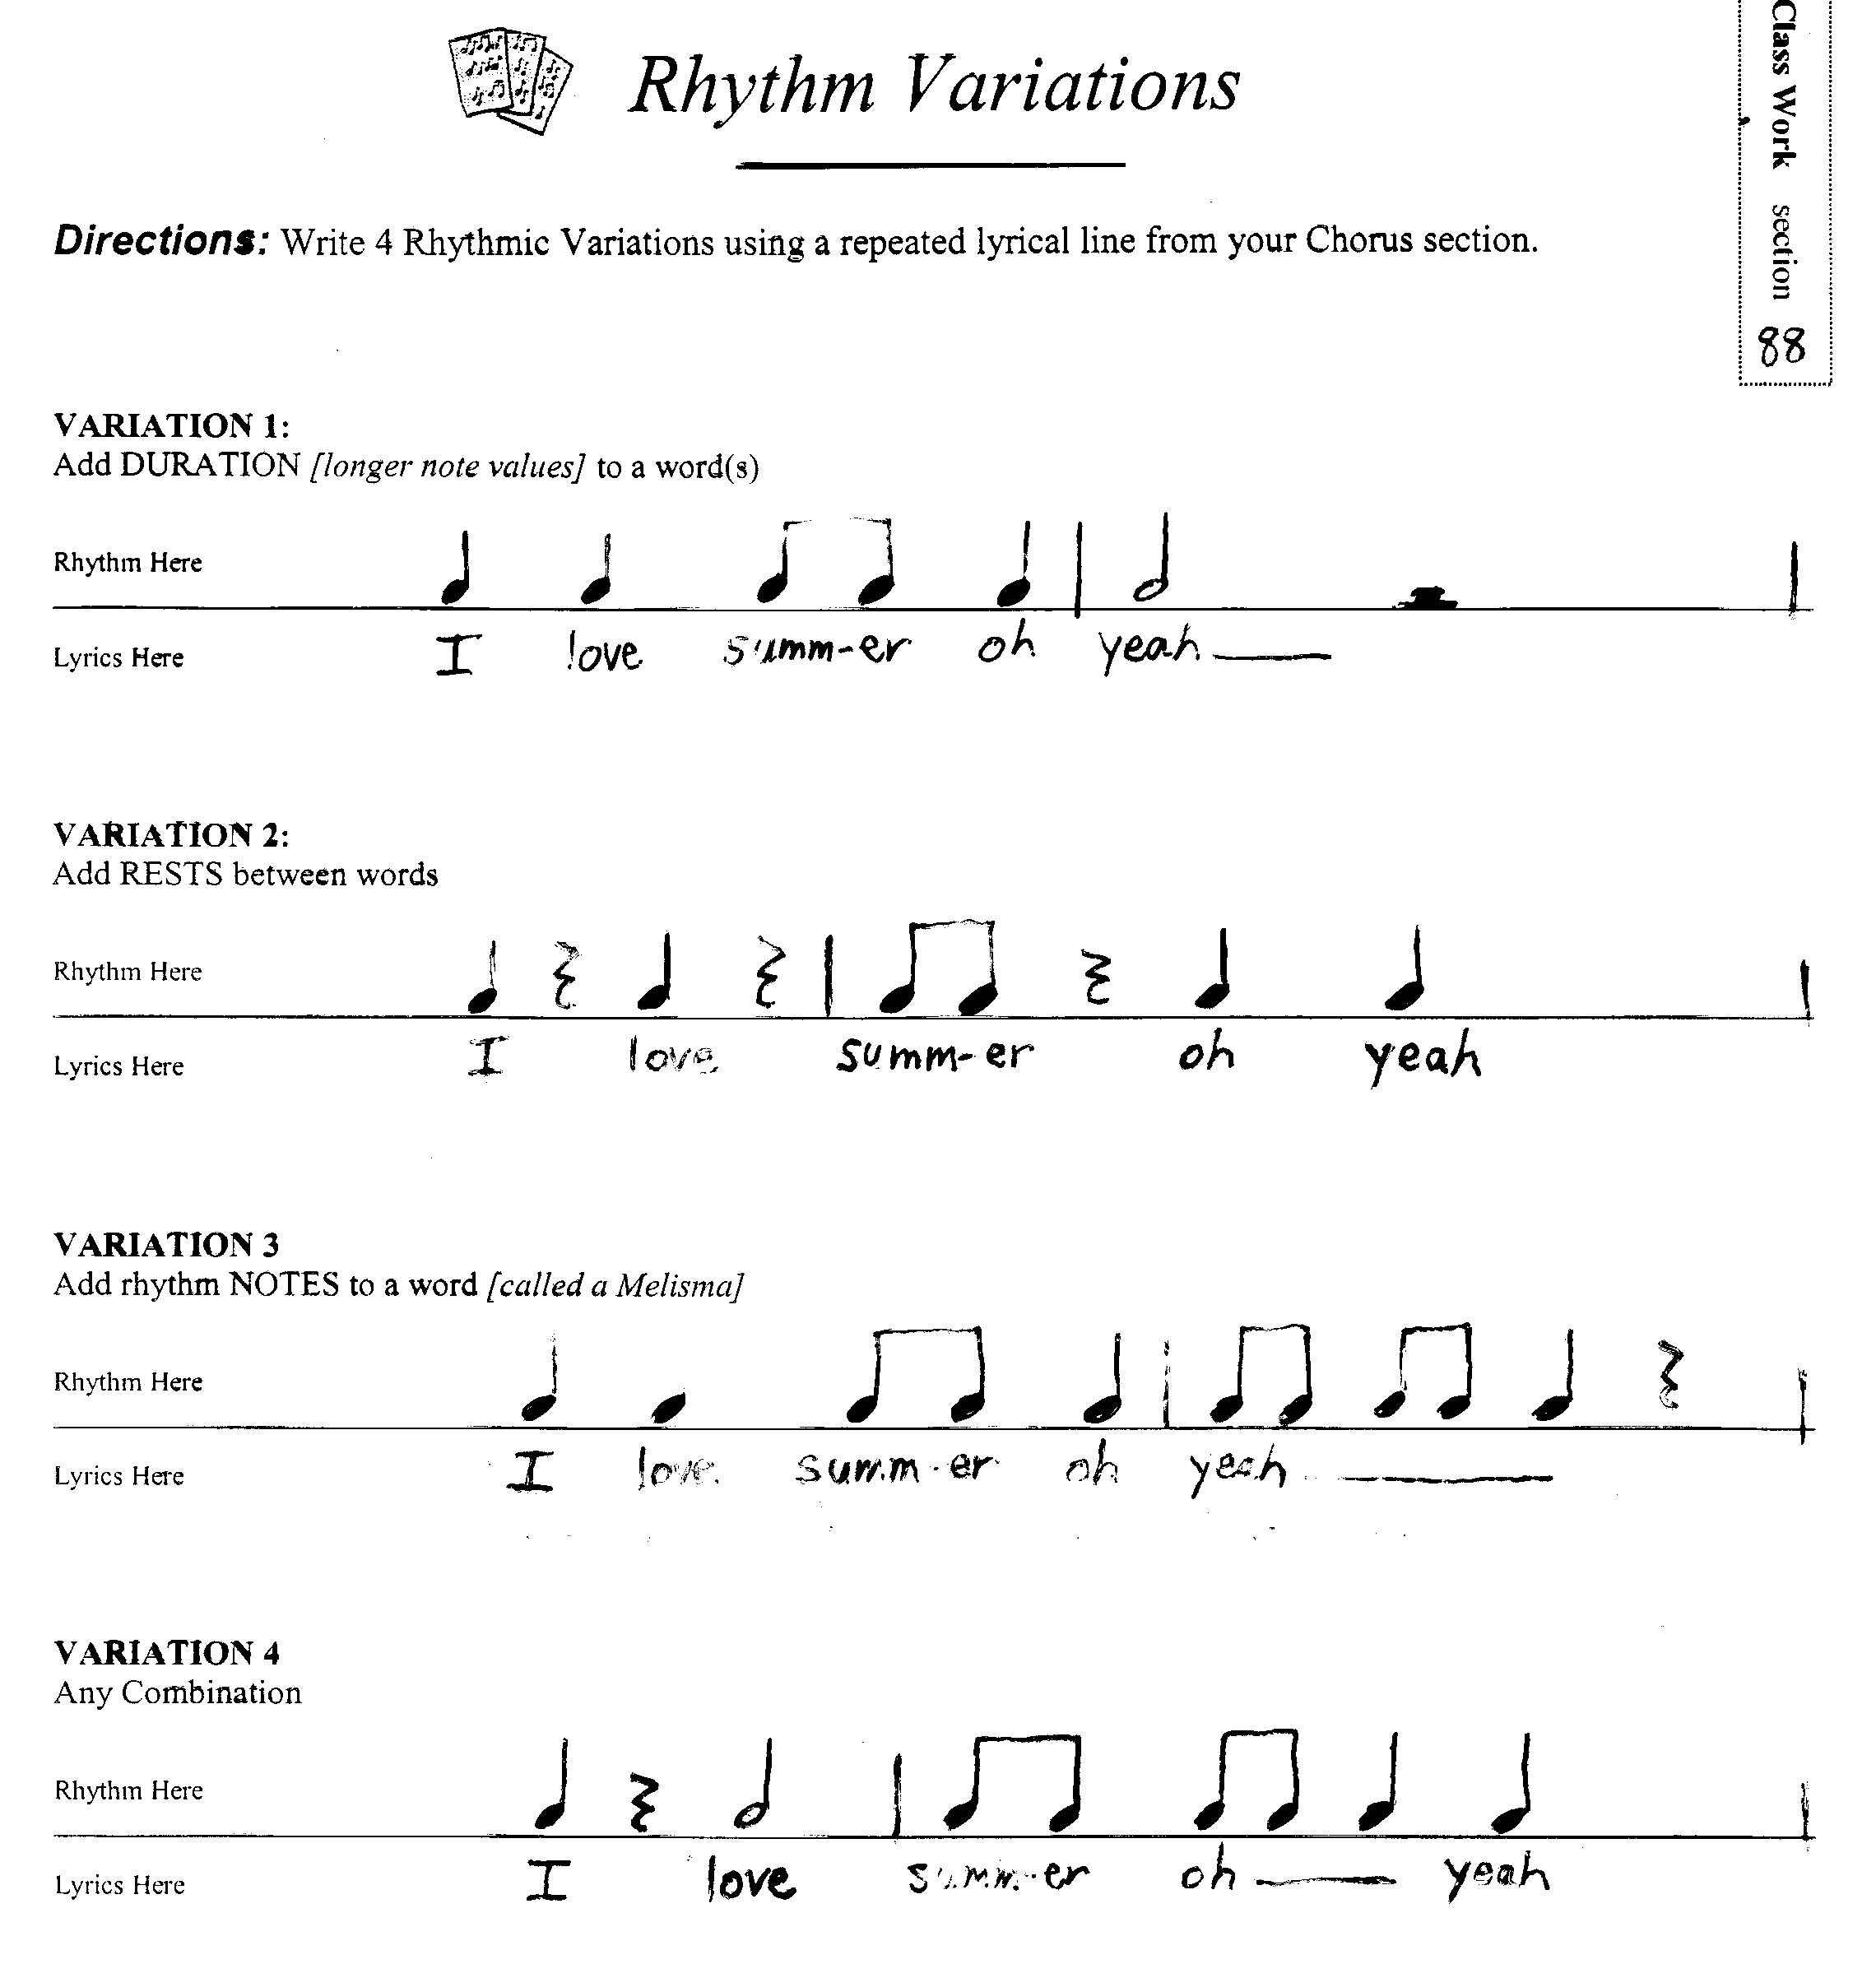
*NOTE: Every lyrical line is different, therefore it is critical to speak the line with the rhythm you have composed to determine whether or not it has good rhythmic flow.

Page 11
********************************************************************************************
Revised 3/25/19
VI. COMPOSE MELODY

Complete the Melody Composing Practice Sheet to practice notating simple melodies—then complete the following steps to apply melody to your song:

* Melody Composing Steps:

Compose Melodic Phrases (for Verses)

- Copy lyrics neatly below staff, then copy rhythms on the lines above. Make lyrics small and neat enough to fit evenly across each 2-measure line of music. Be sure to vertically align syllables & rhythm notation.
- Convert your lyrical rhythms into melody, using the following steps:
- Use all pitches from low E, to high F# (the notes on the Treble staff), as well as Middle C, D, high G, and A (ledger line notes) if you would like a wider range of pitches.
-OR-
- Use only the notes F#, G, A, B, C, D, and E within the Treble staff if you want a simpler melody with fewer choices.
- Use STEP-wise motion (line to space or space to line)-- OR SKIPS.(line to line or space to space) for a melody without large gaps between pitches, or if you like you may include some larger leaps.
c. Accurately notate all rests in staff.
- Check note heads for accuracy of pitch, and make sure that notes are not too large or too small.
- Complete notation with stems, flags and/or beams. Follow all directions on CW28 for stem direction and length, flags and beams,
- Ask for assistance to play it! ☺

Page 12
********************************************************************************************
Revised 3/25/19
Compose Melodic Hook (for Chorus)
*DO NOT Attempt melodic hook composing until steps for composing melodic phrases have been mastered.

Directions: Follow the steps below for the option you chose earlier when writing the format of your lyrics. In all examples, please consider your “Pitch Contour”, or direction that the note heads in your melody move across the staff (low-high, high-low, static, or some combination)

Option #1 Format (“I Love Rock N’ Roll” –lines 1 & 3 same lyrics)

- Copy lyrics and rhythms onto staff page.
- Write in one pitch contour choice for both lines 1 and 3—complete different contour choices for lines 2 and 4.
- Following your contour, compose a melodic phrase for line 1 that includes at least one skip.
- Copy the melodic phrase exactly into the staff of line 3 (the repeated lyric/rhythm line).
- Compose different melodic phrases for lines 2 & 4 (w/different lyrics) while trying to integrate the same pitch sequences from your melodic phrases in lines 1 & 3.
- Check your composing; make sure you followed the contour of lines 2 & 4 while trying to integrate pitch sequences.

Option #2 Format (“Saturday Night” –ALL lines same; in rhythmic chant)
  - Copy lyrics and rhythms onto staff page.
  - Draw note heads in 1st space of staff using an X instead of the standard oval shape.
  - Repeat for remaining lines.
  - Complete notation in the staff with stems/beams/flags and rests for all lines.
  - Check your composing; make sure that notation for every line is exactly the same.

Option #3 Format (“Don’t Let Me Down” –ALL lines same lyrics)

- Copy lyrics and rhythms onto staff page.
- Write in one pitch contour choice for both lines 1 and 3.
- Write in one pitch contour choice for both lines 2 and 4.
- Following the contour for line 1, compose a melodic phrase that uses step-wise motion.
- Copy the melodic phrase from line 1 exactly into the staff of line 3.
- Following the contour for line 2, compose a melodic phrase that includes at least one skip.
- Copy the melodic phrase from line 2 exactly into the staff of line 4.
- Check your composing work.

Page 13
********************************************************************************************
Revised 4/3/13
VII. ADD ACCOMPANIMENT

Adding accompaniment to your melodic phrases will create a full sound for your original song. At this point in your composition you will be making artistic choices that will affect the overall sound of your composition. Your attention to detail in these efforts will make a huge difference in your end product of an original song.

Pop music commonly uses a series of two or more chords performed one after another (known as a chord progression) to provide the accompaniment for a melody. For this project our songs will be similar to folk style pop music, using guitar for the accompaniment.

Now you will need to make an artistic decision regarding the chord progressions and appropriate strumming patterns—a rhythmic pattern to which the chords will be played—in order to create the overall sound of the accompaniment. This is a very artistic and critical step in the song writing process, so take pride in putting extra thought into your creative choices. The decisions you make now will create the overall style and feel of your original song.

Chord Progressions
STEP 1. Choose a Popular chord progression below whose mood fits the character of your Verse sections.

Verses

- G / / / | / / / / C / / / | / / / / D / / / | / / / / G / / / | / / / / |
general Mood: Joyous, uplifting feel

- Em / / / | / / / / D / / / | / / / / C / / / | / / / / G / / / | / / / / |
general Mood: Emotional, with an uplifting ending

- G / / / | / / / / D / / / | / / / / C / / / | / / / / D / / / | / / / / |
general Mood: Joyous, ending with anticipation

STEP 2. Choose a Popular Chord Progression below whose mood fits the character of your Chorus section.

Chorus

- C / / / | / / / / Em / / / | / / / / C / / / | / / / / Em / / / | / / / / |
general Mood: Upbeat with emotion/dream-like feel

- Am / / / | / / / / D / / / | / / / / Am / / / | / / / / D / / / | / / / / |
general Mood: Emotional, with dramatic feel and anticipation

- C / / / | / / / / D / / / | / / / / C / / / | / / / / D / / / | / / / / |
general Mood: Joyous, very upbeat

Page 14
********************************************************************************************
Revised 4/3/13
Strum Patterns
STEP 1. Listen how each of the following strum patterns affects the style and feel of a chord progression.

A. 4___ _ _ _ _ __________|________ _ _ _ _ _____|
4

B. 4 ___ _________|__________ _ _|
4
C. 4________ ___|_______________|
4
D. 4__ _________|________________|
4

STEP 2. Choose a strum pattern for the verses of your song. Consider how the strum pattern will affect the musical feel that will accompany your lyrics that tell the story.

STEP 3. Choose a different strum pattern for the chorus of your song. Consider how the strum pattern will affect the melodic and lyrical hook that you’ve composed. This pattern should be considered very carefully, as it should be adding more power to the hook element of this section.

Add Accompaniment Choices into your song sections.

1. Add the chord progression sequence into the guitar chord boxes above each staff for each section of your music.
The first chord of the chord progression will correspond to the first line of your music,
the second chord to the second line, and so on.

2. Add strumming patterns on the Guitar Rhythm line above the staff for all sections.

***See supplemental Examples

Page 15
********************************************************************************************
Revised 4/3/13

VIII. HARMONIZE ACCOMPANIMENT & MELODY

When accompaniment is added to a melody, certain pitches that are sounded in the phrase need to create harmony in order to sound musical. 4/4 Time—the time signature we are using—carries a heavy accent on beat one. Therefore, the pitch that falls on beat 1 in a melodic phrase should be harmonized with its accompaniment.

Additionally, a pitch that ends a melodic phrase is also important. In order for a melodic phrase to sound like it’s ending, the last pitch should be harmonized as well. Complete the steps below to prepare your melodic phrases for harmonizing:

STEP 1. LIGHTLY Circle all melody pitches that fall on a beat 1.

STEP 2. LIGHTLY Circle the last pitch in each melodic phrase—wherever it may fall.
See Example A below:

Example A: Indentifies the pitches by lightly circling them. These are the pitches that will be checked and may be changed to pitches that will harmonize.

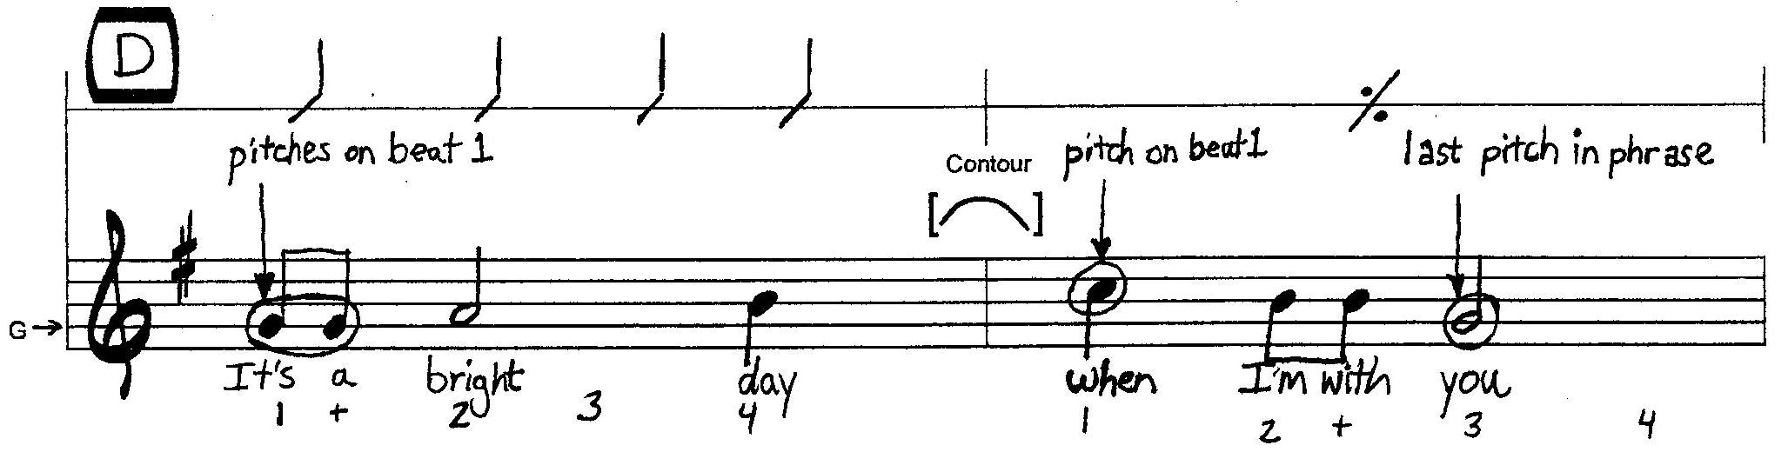

Page 16
********************************************************************************************
Revised 4/3/13

Creating Harmony
Harmony is defined as any simultaneous combination of tones. In order for these tones to sound musical or pleasing to the ear, the tones usually have some kind of relationship that is linked to music theory principles. For example, we are using the harmony created by the chords used in our accompaniment. Each chord is built using the pitches found in a G major scale—that scale is the basis for the key in which we are using for our song. Therefore, our song is in the key of G.

We will be duplicating the pitches that are used in our accompaniment—the chords—with the pitches that are used in our melodies in order to create a harmonious sound at the right time. A pitch that is included in a chord is called a chord tone. Therefore, to create harmony in our melodic phrases at critical points, we will be ensuring that we use a chord tone in the melodies we composed.

Complete the steps below to harmonize your melodic phrases with the chords that are included in your chord progression:

STEP 1. Note which chord you have written in the guitar chord box for each melodic phrase.
(the example in this booklet has a D chord in the box)

STEP 2. Using the chord tones below in Reference:2a, check and/or change the pitches you circled in the previous steps to ensure chord tones are being used at these important places. This step may or may not require changing the pitches in your melodic phrase.

Reference: 2a

CHORD TONES
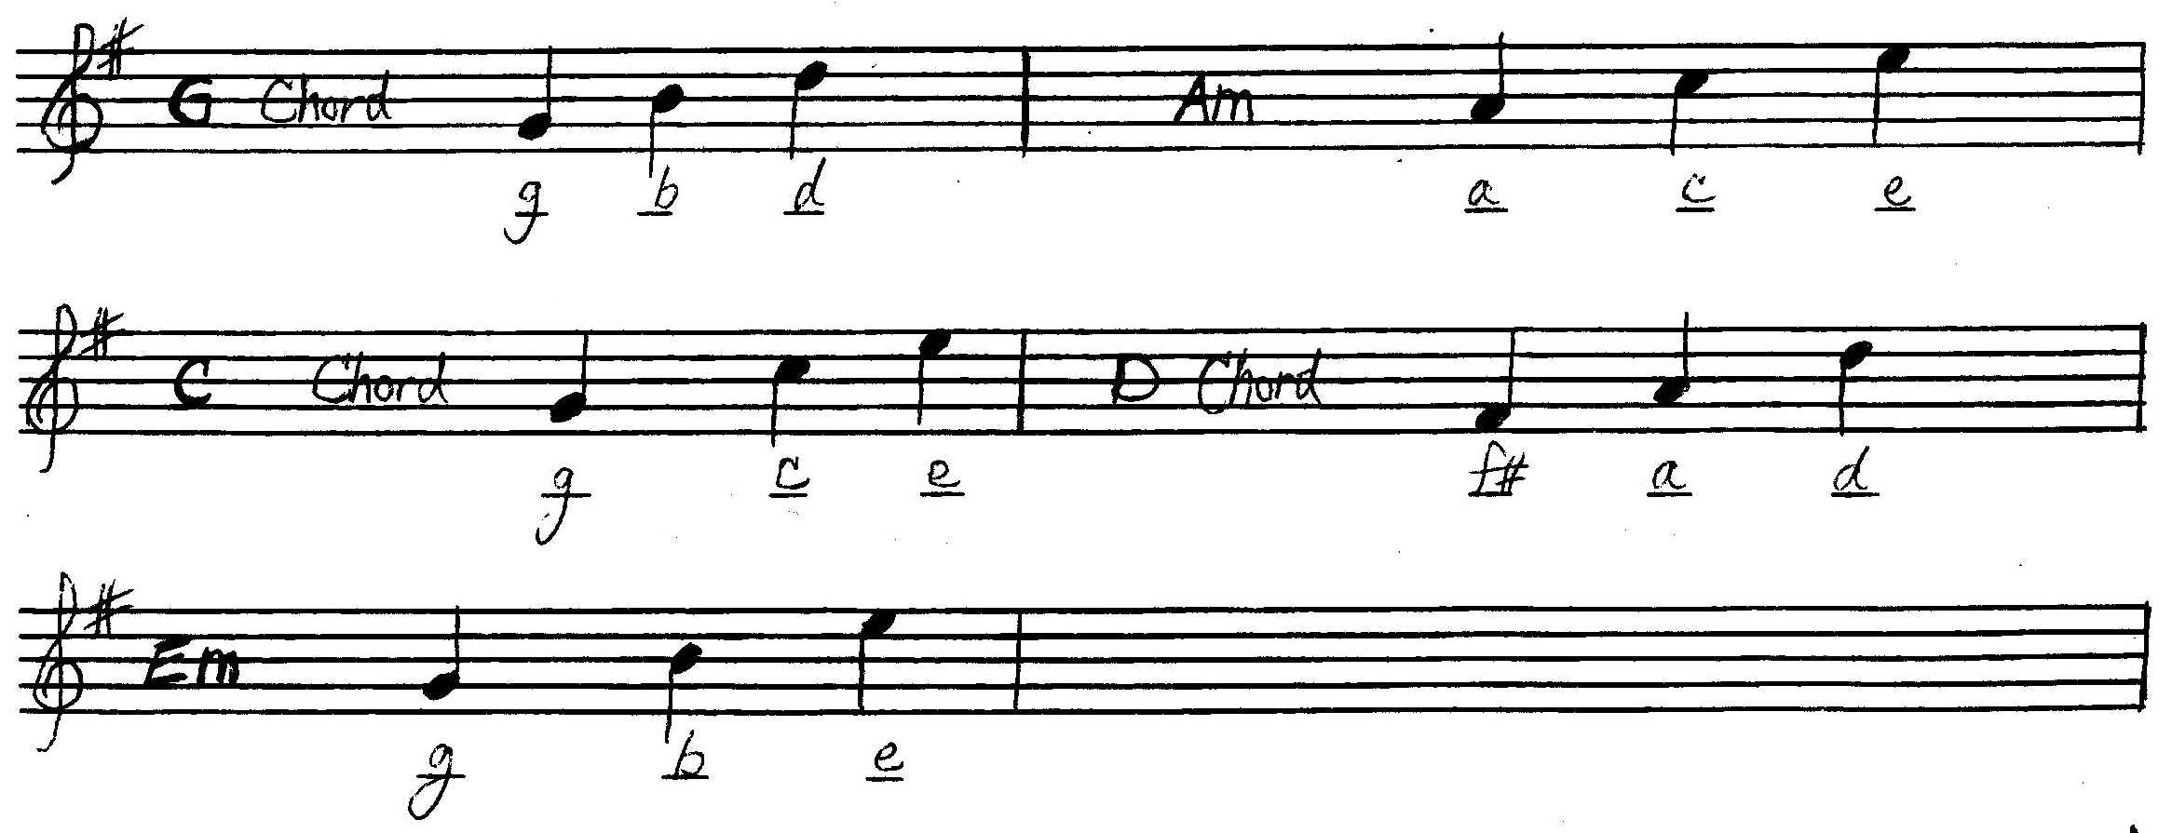

Page 17
********************************************************************************************

Revised 4/3/13

Check and/or Change the pitches (STEP 2 continued)
After referring to Reference: 2a, ensure your chord tones are in the proper place for each melodic phrase AND that any changes made do not change the contour of the pitches. See Example B below.

Example B: Observe the changes made-----NOTE: make sure the changes made DO NOT change the melodic contour.

