North Syracuse Central School District
Allergen List for Foods Containing Pork

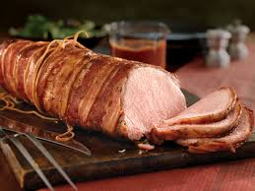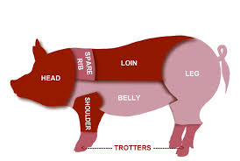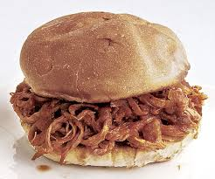

Foods Containing Pork :

Deli Ham Sandwich/Wrap

BBQ Pork Rib Patty w/Sauce

Breakfast Pancake on a Stick – State Farm Brand/Sara Lee

Hoffman Hot Dogs

Breakfast Pizza – Scramble Bacon

Wunderbar German Bologna

Diced Ham in the Lunchable Meal

Pulled Pork Sandwich

Kellogg’s Whole Grain Rice Krispies Treats – All Varieties

Sausage

Lucky Charms Cereal
Golden Grahams Cereal Bar
Rice Krispie Treats

Pork Free:

Jennie-O Turkey Sausage/Turkey-Bacon/Turkey Pepperoni
Armour Beef Hot Dogs
Maid Rite Meatballs
9/25/2023

